- Global Spatial database of Agricultural Land-use Statistics from Food & Agricultural organization of the United Nation ( http://kids.fao.org/agromaps/ )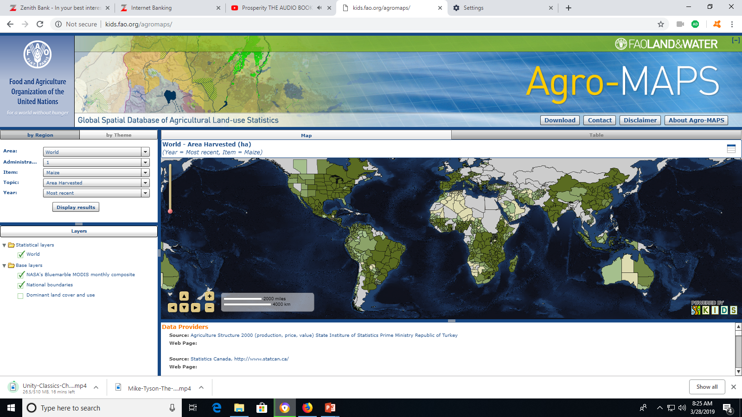
Agro-Map: Shows different crops cultivated in different parts of the world at a designated time, percentage harvested in different areas etc. (http://kids.fao.org/agromaps/ ) Item: Groundnuts in Shell

